Abstract:
In the course of ten weeks, students from the electronics 2 course designed, simulated and tested a multistage amplifier with a feedback loop. The network was built incrementally in a series of four projects, current source, differential stage, gain stage, output stage and feedback stage. Each segment concentrated on a different feature of the network. The result is a functional amplifier with an open loop gain of 600, closed loop gain of 37.

Introduction:

The objective of this quarter-long project is the design, simulation, and test a four stage amplifier with a feedback loop. Its main components were the current source, differential amplifier, a gain stage, an output stage, and a resistive feedback loop.

The main component of the current source network to be used is the CA3046 Transistor array which contains two emitter-connected transistors and three “isolated” transistors, all of type NPN (Figure 1). The most basic type of current source to be investigated is aptly called the Basic Current Mirror (Figure 1). The operation of the basic mirror is based in the assumption that the two transistors used are matched so that they share a gain (β) and subsequent collector current (I_{C}) among other characteristics. While the pre-lab literature predicts that the ultimate output current will be less than the reference current drawn “because of finite base currents”, it may be seen that the output current at the collector of Q2 can surpass that of the reference current.
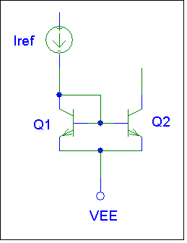
Figure1: Basic Current Mirror

The construction of the current mirror was followed by the addition of the differential amplifier.

The general purpose of the diff-amp is to take two input signals and amplify the voltage difference between them. The same configuration should then be able to recognize when two identical signals are input, and suppress their common components at output. These characteristics are called differential amplification and common mode rejection and can be expressed in combination with each other to describe the quality of the diff-amp. This quality is referred to as the common mode rejection ratio CMRR.

The diff-amp is comprised of two emitter connected BJTs driven by a basic current mirror (Figure 2). The inputs are given at the base of each transistor while a single-ended output is measured at the collector of one BJT. Since the operation of the diff-amp is to merely amplify the difference in voltage between collectors, the decision as to which output is measured is arbitrary and here is determined based on lab literature.
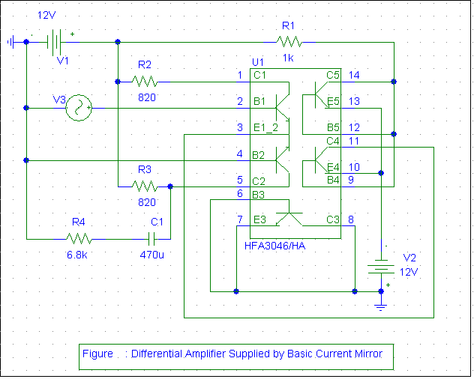

The next portion of the project is designed to reinforce the understanding of multi-stage amplifier design by combining several networks to create a multistage amplifier. By assembling the basic current mirror with the differential amplifier, a gain stage, and then a Class AB output stage, one can make a large (relative to student experience) gain amplifier with a large output voltage swing. Large gain and output swing are important for amplifiers, as they are then more versatile. Having already investigated the operation of both the basic current source and the differential amplifier, the main focus of this session is on the gain and output stages. Because there is a limit to the differential amplifier, a designer requiring greater gain must use multi-stage amplification to meet his or her goals. The process of designing under such conditions can be thought of as the reconciliation ov design specifications and design constraints.

In figure 3, the gain and output stages have been added to the previous week’s network.

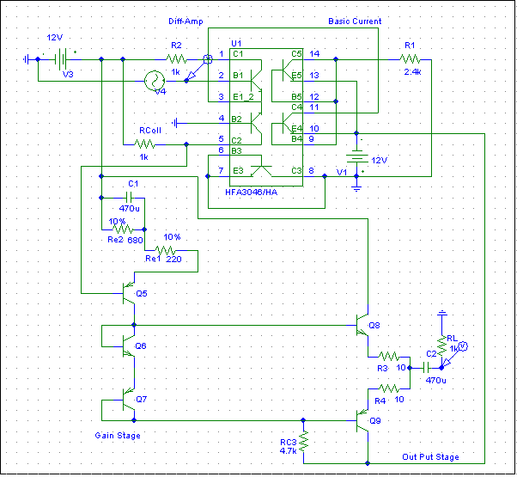
Figure 3: Multi-Stage Amplifier

The basic function of the added stages are to take the signal from the differential stage, amplify it further and deliver it as a steady, whole signal to the load. .

Discussion of its basic function is important because it must be designed according to the output of the previous stage from which it takes its input. In this particular network the differential is designed so that it will deliver a signal with a DC voltage of 9.5 volts. Considering this, the gain stage must be designed so that while it draws from the same power source, its input will sit at or around 9.5volts.

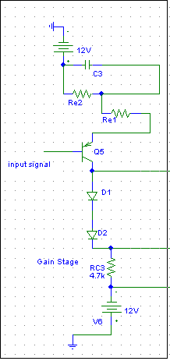
Figure 4: Gain Stage

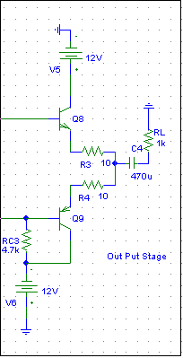
Figure 5: Output Stage

The subsequent project is designed to improve upon the multi-stage amplifier of by adding a feedback loop to the present amplifier design. Having assembled the basic current mirror, differential, gain, and Class AB output stage, one can add a simple feedback network to reduce noise. In actuality, a feedback loop reduces the frequency dependence of a network by forming what is known as a low pass filter. Up until now it has been assumed that the amplifier components have been operating at low frequencies. While this may be relatively true in some cases, our circuits have not been impervious to environmental noise, nor have the input signals been isolated in the low frequency regime. As such it is not only necessary but also beneficial to consider expanding the frequency range of our network.

Based on lecture material and lab literature it has been determined that the frequency response of our network is dependent mainly on a capacitance (either physical or parasitic) in the multistage network. This capacitance acts as a zero or a pole in the transfer function and at certain frequencies, will interfere with the signal sample. Theory states however that this capacitance can normally be evaluated as the Miller equivalent capacitance. This Miller capacitance is connected between the input and output terminals of a circuit, and can also be represented as a combination of two capacitors; one between input and ground, the other between output and ground. This lab assignment requires we only consider the first of these.

Intuitively, the Miller equivalent input capacitance can be considered to be in parallel with the equivalent input resistance of the network, thus resulting in the low pass filter. The result, only low frequency signals may be sampled at the output, eliminating noise.

