ABSTRACT

The EMCR 350 lab was designed and implemented to further students understanding of the PMOS (positive metal oxide semiconductor) fabrication process. This was accomplished through the actual fabrication and testing of functional PMOS devices (transistors and resistors) over nine laboratory sessions. In the testing phase it was discovered that while a normal threshold voltage was achieved with the devices tested, there was a current leakage problem with most of the devices attributable to a phenomenon referred to as threshold voltage shift. In that the devices tested functioned at all, one may argue that the goals of the lab were achieved. Of course the fact that the devices did not function correctly would indicate that the results of the lab were unsuccessful.

INTRODUCTION

A transistor is used to control the flow of current in a circuit, and has a special characteristic in its ability to amplify current. Naturally this is a desirable quality in many circuits, the ability to control and amplify current is essential to specializing and modifying electrical systems. Credit for inventing the first transistor is shared by John Bardeen, William Shockley and Walter Brattain who were jointly awarded the 1956 Nobel Prize in physics for their work. They had initially set out to devise a way of amplifying current without the limits of old vacuum tube technology. By studying the behavior of electrons on the surface of silicon Brattain managed to amplify current when he submerged his device in water. Building on this development, Bardeen isolated the electrical contact in water rather than the entire apparatus. Through experimentation with different materials (germanium among them), and contribution from Shockly (the head of the team at Bell labs), the final product was composed of a base of germanium and two gold contacts just a razors’ width apart. Simple, but revolutionary. Essentially, transistors (among other devices)
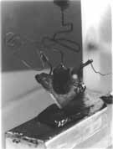
allow for circuits to function as specific tools used in providing solutions to
all sorts of real-world problems. A transistor is comprised of three
dielectric regions, with three contacts and two junctions (figure 1).
This makes it a bipolar junction transistor. They can be characterized as NPN
or PNP transistors depending on the arrangement of their composite
materials. Our devices are PNP, because we have P-type wells separated by an N-type region. Each of the three regions has a specific purpose. In PNP transistors, current is applied through the emitter region and flows to and out of the base. As current flows this direction, electrons move in the opposite direction. The third region, attached to the collector electrode is also connected to a positive voltage and essentially acts as a volume control. The more voltage applied, the more electrons are pulled from this heavily doped region. A NPN transistor works in the same way, only current flows from the base to emitter to, and the regions, as the name suggests, are oppositely doped.
Over the course of nine weeks, students used various instructional resources in an attempt to fabricate a batch of functional PMOS transistors. One important factor in accomplishing the goal of the lab was the instruction and guidance of lab instructors in the order and technique of the microelectronic process. Also essential was the process guide provided in MESA (manufacturing execution system application). This “manual” contained step-by-step directives for all of the processes necessary for the PMOS process. However, the most vital component to the success of the lab goal was a theoretical and practical knowledge of the PMOS sub-processes.
The fabrication procedure is, at its core, a series of smaller procedures that either add or remove material from a silicon wafer. The PMOS begins as a single crystal of silicon in wafer form.
It is put through a series of chemical baths, referred to as the RCA Clean process (figure 2), in which organic, inorganic, and other naturally occurring residues are removed. The first bath is a mixture of ammonium hydroxide, hydrogen peroxide and water (referred to as “APM” for “ammonium hydroxide mixture”). The wafers are soaked for fifteen minutes to remove organics like fingerprints. Wafers are then moved to a bath of distilled water where they are soaked for five minutes to remove any chemical traces of the APM. The next soak if for one minute in hydrofluoric acid buffered with water. This serves to remove any silicon dioxide that may have formed as natural oxidation occurs. Again, the wafers are moved to a five minute bath of distilled water to remove chemical residue, then on to the hydrochloric peroxide mixture or “HPM”. The HPM is made of hydrochloric acid, hydrogen peroxide, and water. A fifteen-minute soak in this bath will remove inorganic materials such as metals. Naturally, another five-minute bath in distilled water follows, then finally the wafers are put into a spin-rinse-dry apparatus. To ensure the process is successful a particle counter is used. The wafer is placed in a chamber where it is scanned with a light source. The reflected light is then optically analyzed to determine the change in wavelength and frequency. These changes indicate the approximate number and size of the particles on the wafer. The result of RCA clean is a reduction in the number of particles.
The wafer then undergoes a sub-process called oxidation, where silicon dioxide (SiO2) is chemically formed on the wafers inside a furnace. Silicon dioxide is an important material to integrated circuits because of its high dielectric constant. A dielectric property is a value by which a material is said to be nonconductive. With a value of 3.9, silicon dioxide efficiently blocks electrical activity and is thus considered a good insulator. This of course is important for controlling the flow of electrons through the device, and protecting certain areas from being adversely affected by current flow. Additionally, oxide layers serve as masks for other processes. In the same way that a stencil only allows paint to deposit in certain areas of a surface, so too does oxide for other process like diffusion. We refer these layers of oxide as “sacrificial.” Another reason SiO2 is used in integrated circuits (as opposed to other materials with high dielectric properties) is the excellent interface it forms with the silicon substrate.
Because the substrates used are single crystal silicon, thermal processes affect the molecular bonds within the crystal structure. Rapid and extreme thermal stress, can damage the crystal affecting its ability to conduct. To avoid this, furnace processes are divided into stages, where wafers are subjected to gradual changes in temperature. High temperatures are needed to induce chemical reactions. In order to change the molecular structure of a material, one must add or remove atoms from the original structure. Causing such changes requires energy, which is provided in the form of heat (900-1200ºC).
The molecular change (chemical reaction) affected when growing an oxide onto silicon can occur one of two ways:
Wet oxidation is achieved when silicon is exposed to water vapor in the furnace process $\left(\text{Si}+H_{2}O\vec{}{\text{SiO}}_{2}+2H_{2(g)}\right)$. The reaction at the surface of the wafer consumes the silicon, causing a depletion of the wafer thickness as the oxide expands. 46% of the final with of the oxide extends below the original surface of the wafer.
Dry oxidation is achieved when silicon is exposed to pure oxygen (in gas form) in the furnace $\left(\text{Si}+O\vec{}{\text{SiO}}_{2}\right)$. Because there is a higher concentration of oxygen in this chemical reaction, the diffusion process is somewhat slower than that of wet oxide growth. The result also yields a thinner, denser silicon dioxide layer, providing better insulation.
Regardless of the method, the temperature at which the reaction takes place must be strictly controlled in order to produce the desired oxide thickness. To prevent incidental reactions from taking place during the warming phase, the wafers are surrounded by an inert gas, referred to as the ambient and usually nitrogen. Once the desired temperature is reached, the furnace is then flooded with the appropriate chemical to induce oxide growth. While the type of ambient and oxide thickness desired cause variations in the duration of the furnace process, the stages of the system are essentially the same (figure 3). Naturally to ensure the appropriate thickness has been reached, the wafer must be inspected. A nanospectrometer is used to determine the depth of an oxide “field.” Light of a particular wavelength is directed perpendicular the wafer surface, the deeper the oxide, the less light will be reflected from the silicon surface. The wavelength of the reflected light indicates how deep/thick the oxide is.
The wells of the PMOS transistor are also formed through a furnace process. In order to form a p-type region in the device, the properties of the area must be changed. By adding atoms to change the majority carrier type in that part of the wafer, we essentially add holes or electrons (depending on the type of atom diffused) to the crystal lattice. Diffusion moves material from an area of high concentration to low concentration. By concentrating impurity atoms at the surface then applying heat, we can partially deposit them onto the wafer with a sub-process known as “predepositon.” Once complete, the impurity source is removed from the surface and an extended exposure to heat will effectively drive / diffuse what remains (the dose) into the wafer. With the use of a masking oxide, we can create the wells of the transistor. The dimensions of the well are affected by several factors most important of which are temperature, the diffusion coefficient of the impurity and the concentration of the impurity at a given point. Temperatures between 900 and 1200 degrees C are most commonly used for diffusion processes. Higher temperatures tend to adversely affect the ability of impurities to move into the wafer. This quality of an impurity is the second major factor and is referred to as its diffusion coefficient and is a function of its activation energy and temperature: $D=D_{O}\text{exp}(−E_{A}/\text{kT})$. The last factor affecting the shape of the well has to do with the concentration, or amount of atoms present at any point below the surface of the wafer. As a result of diffusion, atoms below the surface of the wafer have a lower concentration, and also lower energy than those above them.
There naturally then comes a point in the diffusion process where the concentration of the impurity will equal the concentration of impurities that pre-exist in the silicon wafer (usu. from Cz crystal growth). This point is the junction between P-type and n-type regions; the “junction depth” and the depth of the p-well (figure 4). The junction depth is measured through a sub-process called groove and stain. Control wafers that have accompanied the device wafers through the PMOS process are used to determine this measurement. A grinding wheel of diameter D is applied to the surface for about a minute after which the grooved area is stained with a copper ammonia solution. Under a microscope two measurements are recorded, the distance from the surface of the wafer (outer edge of the stain) to the edge of the bare silicon layer (M), and the distance of the grooved area and the stained area together (N). Converted to metric units the junction depth is given by $X_{J}=(M∗N)/D$. During the diffusion process, the interface between the impurity and the silicon not only moves down but sideways as well. Lateral diffusion describes the movement of the impurity interface under the edge of the oxide diffusion mask (figure 5). While this affects the width of the p-well, it also affects the channel length of the transistor and other devices and should be considered when implementing diffusion processes.
The act of creating the p-wells essentially changes the electrical properties of the region. The well contains more holes in its structure and, as desired, better supports electrical conductance than the surrounding area. The degree of this support is conductance, the inverse of resistance. Naturally, we wish to quantify the amount by which the resistance in the p-well has been reduced. Four point probe accomplishes this by measuring a voltage drop across a series of pin points on the wafer. The pins are fixed in alignment and placed against the wafer surface. A current is applied from and to the outer pins while the voltage difference between the inner pins is measured. By Ohm’s law, the ratio of voltage to current defines the resistance in the wafer.
Like the oxidation process, the diffusion process involves placing material at the surface of the wafer. Layers like the oxide mask or impurity source for dopant predeposition must be removed after they’ve served their purpose. This is accomplished with a chemical process known as etching. Wafers are typically soaked in a solution of hydrofluoric acid for several minutes (depending on the type and thickness of material). The HF mixture at room temperature etches SiO2 at a rate of 100 to 1000Å per minute depending on the density of the layer. To ensure the oxides are completely removed, typically control wafers are put through a step-etch process where different etch times are used to etch different areas of a single oxide layer. The average etch rate can be determined by examining the ratio of oxide removed in a certain area to the time that area spent in the HF solution.
One can see from a cross-section of the PMOS transistor that there are several layers that make up the device. The pattern of each layer is created through the process of microlithography. Light sensitive material called photoresist is coated over the wafer after an oxide layer has been grown. Once this material is cured through a short heating process “soft bake” it is moved into an exposure machine. A reduction stepper emits light to a patterned mask or “reticle.” The mask usually made of glass holds a pattern made of metal emulsified film on one side. Areas not covered by this film allow the steppers light to pass through then onto a series of lenses reducing the light pattern and finally onto the coated wafer. The mask ensures that light will only expose certain areas of the photoresist at the wafer. Once irradiated, the light sensitive chemicals burn in much the same way camera film does, transferring the pattern from the mask onto the wafer. (figure 6). The wafer is then removed from the stepper and inspected. Each mask, in addition to the device patterns required, include a series of measurement marks used in quantifying the degree to which the exposure was successful. When second, third and fourth level lithography are involved, fiducial marks on the mask become important in determining the degree to which each exposed pattern squarely lays over the one below it. Once the mask pattern is determined to have been successfully transferred to the wafer, the remaining photoresist goes through a “hard bake” to solidify it in preparation for the etching process. The resist pattern now acts as a reduced mask through which buffered HF will remove the oxide in unprotected areas. (figure 7). Once the oxide is etched, the resist mask is removed by one of several methods. Many companies develop specialized chemical removal solutions depending on their needs and resources, others use a dry process which uses an oxygen plasma system to “burn” or “ash” the resist off. The RIT PMOS process uses the resist ash method most often, when the time required for this process is restricted, a simple solution of acetone and water removes the resist in a matter of seconds.
The lithography process is used to create patterns in more layers than oxide. It is used for aluminum transistor contacts as well. Aluminum is considered the top layer of the PMOS transistor, and is the interface between input/output and the transistor itself. To form this layer we use an aluminum sputterer, that deposits a vaporized layer of metal over the entire wafer. An aluminum target is barraged with ions (usu. argon) at high energy. When encountered, some atoms are knocked loose and transported to the wafer surface. To ensure the correct dose of aluminum has been deposited to the wafer, we analyze the sputtering yield. This is the ratio of target to incident atoms which is directly proportional to the energy of the incident atoms. Once the aluminum layer has been put down, patterned through lithography and the resist pattern hardened, unwanted aluminum is simply etched away.
With so many process steps to be conducted and repeated, a system for tracking and recording which steps have been done is essential to the successful manufacture of devices. MESA (Manufacturing Execution System Application) is a software program that records and documents the PMOS process. When properly used, MESA can identify for a user exactly which step in the process the devices are in and which sub-process should be applied next. When a laboratory process takes several weeks to complete, MESA is an indispensable tool for quality assurance. Many steps such as RCA clean are repeated in the course of manufacture, and several layers are created through the same lithography process. To ensure the appropriate processes are implemented in the correct order, MESA serves as a type of manual for outlining the PMOS process.

PMOS PROCESS
(5 control wafers C1-C5, 5 device wafers D1-D5)
Silicon
Oxide
Resist
Gate Ox
Aluminum
Boron/p-well
Process Step | Cross Section
1. Scribe all: With a diamond tipped pen, score the back of each wafer with the lab section, and identifying number C1-D5. | 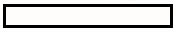
2. Four point probe C1-5: Four prongs are lowered to contact wafer. As current is applied across two prongs, voltage is measured across the other two.
3.RCA Clean all: Series of chemical baths removes unwanted oxide, organic and inorganic particles.
4. Wet Oxide Growth all: Wafers are placed in furnace with H2O and oxide layer is grown in prep for lithography. | 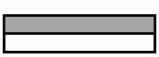
5. Step etch C1, Bare etch C2-4: Wafer C1 is step etched to determine the etch rate of the oxide. | 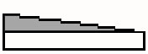
6. Lithography D1-5: Wafers are masked with photoresist, then exposed w/ the GCA G-line Stepper | 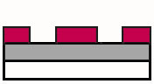
7. Oxide Etch D1-5: Unmasked oxide is removed in buffered HF etch creating the space where the p-wells will be. | 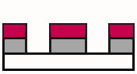
8. Strip Resist D1-5: Remaining photoresist is removed with ashing process (in this particular step it was accomplished with acetone). | 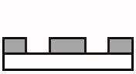
9. RCA Clean all: refer to step 3.
10. P-Type Diffusion all: Spin-on liquid Boron dopant and diffuse into the bare portion of the wafers with furnace process. | 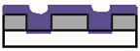
11.Oxide Etch D1-5, C2-4: Remove the remaining oxide from the wafers. | 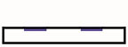
12. RCA Clean D1-5, C3-4: Refer to step 3.
13. Wet Oxide Growth D1-5, C3-4: Field oxide growth, refer to step 4 and also serves as boron drive-in. | 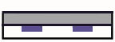
14.Step Etch C5: Wafer C5 is step etched to determine the etch rate of the oxide, and boron layer as well as where they meet. | 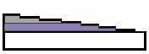
15. Groove and Stain C2: Measure the depth of the predeposited boron into the wafer.
16. Four point probe C1-2: Refer to step 2. Quantifies the change in resistance from the beginning wafers to the doped ones we now have.
17. Wet Oxide Growth C3-4: Drive in and additional oxide growth, already completed in step 13.
18. Oxide Etch C3-4: Remove the remaining oxide from the wafers. | 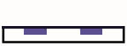
19. Groove and Stain C3: Determine the junction depth of the boron drive in. This is the junction depth of the well.
20. Four point probe C3: Refer to step 2. Quantifies the change in resistance from the beginning wafers to the doped ones we now have.
21. Lithography D1-5: 2nd level refer to step 6. | 
22. Oxide Etch D1-5: Refer to step 7. | 
23. Strip Resist D1-5: Refer to step 8. | 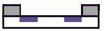
24. RCA Clean D1-5, C4-5: Refer to step 3.
25. Dry Oxide Diffusion D1-5, C4-5: Wafers are placed in furnace with only dry O2 Thin gate oxide is created. | 
26. Lithography D1-5: 3rd level. Refer to step 6. | 
27. Oxide Etch C4: Remove the gate oxide from the wafer, in prep for next step.
28. Groove and Stain C4: Refer to step 15. To determine the effect of previous furnace process on junction depth.
29. Four point probe C4: Refer to step 16. To determine the effect of previous furnace process on sheet resistance.
30. Oxide Etch D1-5: Remove unwanted oxide from unmasked areas of the wafers. | 
31. Strip Resist D1-5: Refer to step 8. | 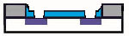
32. RCA Clean D1-5: Refer to step 3, only 10 sec in HF bath.
33. Aluminum Deposit D1-5: Sputter aluminum coat over wafers to create the contacts for the final devices. | 
34. Lithography D1-5: 4th level, Refer to step 6. Creation of contact cuts. | 
35. Aluminum Etch D1-5: Etch away unmasked aluminum from wafer. | 
36. Strip Resist D1-5: Refer to step 8. | 
37. Sinter D1-5: Use furnace to bond the aluminum contacts to the other gate components, decreasing contact resistance.
38. Test D2-3: Apply voltage to determine if the devices behave as predicted according to their dimensions.

SUMMARY OF RESULTS

Initial 4-Point Probe | Avg. of Control Wafers
Voltage | .806 volts
Current | 19.853 Amps
Resistivity | 9.20Ωcm

Initial Oxide Growth (5000 Angst. Desired) Step Etch on Wafer C1
Wafer | Ox Thickness (Angstroms) |  | Minute | Å Etched
C1 | 4807 |  | 0-1 | 1163
C2 | 4772 |  | 1-2 | 1006
C3 | 4811 |  | 2-3 | 862
C4 | 4781 |  | 3-4 | 877
C5 | 4779 |  | Avg. (Å/min) | 977
Avg. | 4790 |  | To etch 5000 Å: | ~6 min

Spin on Boron Glass After Pre-Dep Step Etch on Wafer C5
Wafer | Avg. Thickness (Å) |  | Area | Thickness (Å) | Area | Thickness (Å)
C2 | 1973 |  | 1 | 5709 | 6 | 2384
C5 (w/ oxide) | 5250 |  | 2 | 4819 | 7 | 1620
 |  |  | 3 | 4621 | 8 | 769
C2 Junction  Depth (after boron predep) | 1.11um |  | 4 | 4382 | 9 | <100
C2 Junction  Depth (after boron predep) | 1.11um |  | 5 | 3412 | 10 | <100
C2 Junction  Depth (after boron predep) | 1.11um |  | Areas 1-4 Etch rate of 309 Å/min
 |  |  | Areas 5-9 Etch rate of 876 Å/min

Resistivity by Area of Wafer C1 Resistivity of Wafer C2
Area | Thickness (Å) | Resistivity (Ωcm) |  | Avg. Voltage (V) | Avg. Current (Amp) | Avg. RS (Ω/sq)
A | 4818 | 212.82 |  | 0.817 | 51.8 | 71.45
B | 3655 | 178.07
C | 2649 | 177.25 |  | RS * XJ = Resistivity = 7.85 E-3
D | 1787 | 178.32
E | 910 | 176.83
F | <20 | 76

Junction Depth, Sheet Resistance, and Resistivity for Wafer C3 and C4
Wafer C3B  (Boron drive in only) |  | Wafer C3A  (Boron drivein & fox) |  | Wafer C4A  (Boron predep, drivein/fox & gox)
Junction Depth | 1.3um | Junction Depth | 1.7um | Junction Depth | 1.6um
Sheet Resistance | 103.02Ω/sq | Sheet Resistance | 137.49Ω/sq | Sheet Resistance | 128.76 Ω/sq
Resistivity | 1.34E-4 Ωcm | Resistivity | 2.34 E-4 Ωcm | Resistivity | 2.06 E-4 Ωcm

Gate Oxide Measurement from Wafer C5
C5 Avg. Oxide Width (Å) | 646

MICROTEC Simulation Results
Boron drive in (Gaussian Profile), fox & gox
Junction Depth | 3.2um
Channel Length | 4.0um
Silicon Consumed | .24um

Lithography Offsets
Wafer D1 | 1st Level | X-Offset | Y-Offset |  | Wafer D2 | 1st Level | X-Offset | Y-Offset
 | 2nd Level | -2 | +1 |  |  | 2nd Level | -2 | +1
 | 3rd Level | 0 | -2 |  |  | 3rd Level | No Data
 | 4th Level | -2 | -4 |  |  | 4th Level | -2 | -3

Wafer D3 Lost in 2nd Level

Wafer D4 | 1st Level | X-Offset | Y-Offset |  | Wafer D5 | 1st Level | X-Offset | Y-Offset
 | 2nd Level | -2 | +1 |  |  | 2nd Level | -2 | +1
 | 3rd Level | 0 | -2 |  |  | 3rd Level | 0 | -1
 | 4th Level | No Data |  |  |  | 4th Level | No Data

Cross Section of Final Transistor
Field Oxide
Aluminum
Silicon
P-Well
Gate Oxide

TEST DATA

Family of Curves for D4 from L010323
Device | Dimensions W _{X} L (um) | Ratio of Dimensions | Saturation Amperage IDS (mA) | Ratio of IDS
1 | 80X20 | 3/.25=12 | 1.637 | 10.4
2 | 30X90 | 3/.25=12 | 0.157 | 10.4

Threshold Voltage for D4 from L010323 Inverter Test for D4 from L010323
Device | Threshold Voltage VT (V) |  | Device | Dimensions  W _{X} L (um) | Predicted Gain | Actual Gain
1 | 1.26 |  | 1 | 20X30: 120X20 | 3 | 3.28
2 | 1.52 |  | 2 | No Data | 2 | 2.27

ANALYSIS OF RESULTS
One of the most promising indicators in the collection of results was the evolution of the resistive property in our devices. As we changed the electrical properties of the wafers through diffusion processes, periodic calculations of resistivity revealed that indeed the devices were becoming more conductive as each diffusion step was completed. The PMOS process results also illustrated the relationship between oxide thickness and resistance. As oxide layers were grown, increased sheet resistances were measured. Most importantly though, the testing results concretely connected the concepts behind the process to the electrical device relationships we know so well.
The initial resistivity of our wafers was calculated to be 9.2Ωcm, within the range that had been indicated by the manufacturer. After the creation of the p-type regions with boron, the resistivity was calculated to be 7.85E-3Ωcm, a considerable difference. This confirmed the prediction that adding holes to the lattice, would increase conductivity. Subsequent furnace processes, increased the junction depth of the p-wells causing further decreases in resistivity.
Process Step | Resistivity (ohm-cm)
Initial 4-point probe | 9.20
Boron predep | 7.85 E-3
Boron drive-in | 1.34 E-4
Field oxide growth | 2.34 E-4
Gate oxide growth | 2.06 E-4

Increased junction depth of the p-wells during the course of the PMOS process is unavoidable. Oxidation processes by their very nature consume silicon in turn affecting the dimensions of the devices. With this correlation in mind, experimentation over several years in the RIT fab as led to recipes that allow us to control and predict the affects of furnace processes on our devices. One useful tool in understanding the affect of heat on dimensions is the MICROTEC simulation program. Although the software is limited in capability, it allows users to see the influence of thermal processing on junction depth as well as lateral silicon consumption. The simulation software did not allow for the analysis of junction depth at different points in the series of thermal processes we conducted. Instead, users had to rely on the end result of a simulation that included several anneals, thereby eliminating the affects or non-affects of ramping.
The simulation conducted included all of the furnace processes required for our PMOS fabrication either in the form of an oxidation (the program only allowed for one) or an anneal.
Simulation | Time (min) |  | Process | Time –ramping (min)
Boron Predep | 10 |  | Boron Predep | 5
Drive in / FOX | 45 |  | Drive in / FOX | 45
GOX | 20 |  | GOX | 20
Total Time | 75 |  | Total Time | 70
Final Junction Depth | 3.2um |  | Final Junction Depth | 1.6um

The difference between the simulated and measured junction depth is oddly 1.6um. The fact that MICROTEC predicted the junction would be twice as deep as it actually was can be explained by many things. As suggested above, the affects of ramping some furnace processes may have had an affect on the junction. While it is understood that ramping occurs in an inert gas designed to minimize or eliminate oxide growth until the desired conditions are reached; there was no way to confirm that ramping had absolutely no affect. Another more plausible explanation for the difference is contamination of the furnace itself. Before the gate oxide was developed the furnace was first cleaned with a chlorine gas to eliminate other particles in the furnace tube that might interfere or inhibit oxide growth. The other thermal processes used in fabrication did not include this cleaning step, and could have affected the growth of the oxide as well as the junction depth. A third most probable explanation for the difference in junction depths is the “idealization” of the process by the simulation software in which there was no outdiffusion. Conversely, our actual thermal processes were likely flawed with immeasurable uncertainty, poor technique and included outdiffusion into the furnace tube.
One point of interest is the observation that the initial surface concentration of boron during the simulated predeposition had a value of 1.5E20 /cm³ with a temperature of 1050ºC. According to Jaeger’s text, a predeposition or “constant source” diffusion would have a surface concentration equal to the solid solubility limit for a given temperature. In the case of boron at 1050ºC, that value would be closer to 2.5 E20 /cm³. This information would indicate that we should actually have a deeper junction than that of the MICROTEC simulation, yet our measurement was only one half.
Besides junction depth, the other important dimension of the p-wells that affected the performance of the devices was channel length. While not expressly measured in this lab, we used an accepted value of 2.5um as the distance of lateral diffusion. In predicting the performance of a device such as a transistor, this detail reduces the channel length (L) by a total of 5um, a substantial decrease for some devices.
W
L

p-well
drain
p-well
source

gate

Lateral diffusion

The dimensions of our transistors are the elements that allow us to understand and predict the electrical behavior of our devices in a circuit. By controlling the dimensions of the device we control it resistive properties, thereby affecting the amount of voltage allowed to travel across it. This affect was quantified through electrical testing after the actual fabrication process was complete.
The first test conducted was a family of curves test where a voltage sweep is applied from the drain to source (V DS) to determine the maximum current the device can support when a gate voltage is fixed. Because of the nature of the materials used to build the transistors in the PMOS process, there sometimes exists an area of ionic silicon or ionized non-bridging oxygen at the interface between the substrate and gate oxide. These ions can support electrical activity even when none is intended, causing an interface charge to form. To control this, gate oxides are formed with the highest quality possible, annealed in hydrogen and counter acted with the application of a negative voltage between the gate and source (V GS). The magnitude of this potential is referred to as the threshold voltage (VT) and is obviously dependent on the properties and dimensions of the device. When the voltage sweep reaches a point equal to the threshold, the device will turn on supporting current across its terminals. As the sweep continues, more and more current is passed through the device until it reaches a point of saturation. This is the maximum current that can flow from source to drain (ISD) on our transistor, given the threshold voltage we’ve. The higher the voltage allowed at V GS, the higher ISD will be. These relationships are given by the following:
$$\begin{aligned}I_{\text{DS}}=\frac{W}{L}μ_{P}C'\left[(V_{\text{GS}}−V_{T})V_{\text{DS}}−\frac{V_{{}_{\text{GS}}}^{2}}{2}\right] \\ I_{\text{DS}}=\frac{W}{L}μ_{P}C\left[\frac{(V_{\text{GS}}−V_{T})^{2}}{2}\right]\end{aligned}$$
Parabolic
Region

Linear Region

One can see then, that the maximum current supported on a transistor is dependent on the thickness of the gate oxide because of the interface charges mentioned above. Not unexpectedly then, when comparing two transistors of certain dimensions but given the same gate oxide thickness, we could expect the ratio of dimensions to be equal to the ratio of currents. In testing this was not the case however. Where we expected a ratio of approximately 12 to 1 given the dimensions (W X L)of the first transistor was 80X20um (.25 squares) and the second was 30X90um (3 squares). We measured the currents (device 1 1.634mA and device 2 .157mA) and found their ratio to be 10.4. Based on experience with the process and testing procedure, our instructor explained that we should expect a ratio of currents closer to 15 because of lateral diffusion interfering with the actual dimensions of the devices.
Using this information to re-evaluate the ratio of squares, the channel length of the first transistor was estimated to be 15 rather than 20um and the second to be 85 rather than 90um. The new ratio was indeed calculated to be 15.3. Still, far off from the measured ratio of 10.4. The most plausible explanation for this measurement comes from the possibility that there was some mask alignment error that perhaps decreased the width of one or both of the devices. For the sake of illustration, if there were a vertical alignment error on the first transistor the dimension of width would be affected.
This decrease would have to be approximately 10um changing the number
of squares to approximately .285 from .25. The new ratio of dimensions
would be 10.526. The misalignment theory would then easily explain the
result we obtained.

The next test performed measured the threshold voltage by fixing the current and applying a voltage sweep to the device. By measuring the voltage at the point where the device turns on, we can quantify VT. Graphically we would observe the current through the device, and expect to see nothing until the voltage has reached VT. At that point, current would rise with the increasing voltage sweep and eventually saturate as before. Upon completing the test, the threshold for the first device was 1.26 while the second was 1.52. However, it was observed that for the second device, we were able to measure a distinct and constant current before the expected threshold was reached. This excess activity is called leakage and for obvious reasons is a fatal flaw in our transistor.
To explain this we examine a phenomenon called interface charge shift. There is a quantity called the voltage shift (ΔV) that is inversely related to the capacitance of the oxide layer in a region. A high capacity oxide such as a gate oxide would limit this shift causing little change in its magnitude. On the other hand, an oxide with a low capacitance such as an insulating/separating field oxide would support a large voltage shift if it were to be given such a voltage. In order for the latter situation to take place, lateral diffusion would have to be excessive (observe the dotted lines) to the point that the distance between devices is small enough to support activity despite the field oxide above it.
FOX
FOX
Gate
Wells

A thick field oxide test revealed a VT of –3volts. The expected value was closer to twenty-four volts for a sufficient insulator. Using the voltage shift relationship to examine the ratio of capacitance of the two oxide regions we found: $C_{\text{OX}}^{'}=\begin{matrix}\frac{1}{\text{700}} & \text{or} & \frac{1}{\text{5000}}\end{matrix}$ a difference of a factor of eight. This difference in thickness would indeed explain the unexpected threshold voltage.
The last test performed was an inverter test measuring the gain allowed by our devices. We describe this quantity mathematically as: $\text{Gain}=\frac{{ΔV}_{\text{OUT}}}{{ΔV}_{\text{IN}}}$ . The inverter device essentially behaves as a voltage divider.

Device  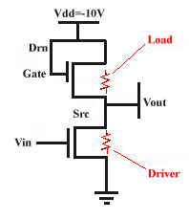 | Equivalent Circuit  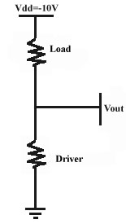

Using basic circuit analysis, we can predict the output voltage of the circuit using the voltage divider equation: $V_{\text{OUT}}=V_{\text{DD}}\left(\frac{R_{\text{driver}}}{R_{\text{driver}}+R_{\text{load}}}\right)$. We can also predict the gain of the circuit using the dimensions of the resistors included: $\text{Gain}=\sqrt{\frac{L/W\text{Load}}{L/W\text{Driver}}}$ . If we wanted to minimize that gain, we can see that the drive resistor should be as wide as possible with a narrow channel length to offer the least resistance while the load should have a thin width and wide channel length. This would bring the ratio of resistors to a small value, further and further decreasing the output voltage. If we had a perfect load resistor, we can see the output voltage would drift toward –10V until the potential difference between VOUT and VDD equaled the threshold voltage. At that point (in this device -1.5V) the device would turn off. Because however we do have resistors with tolerances, we would expect that upon sweeping VDD to –10V that the output would only come to –7 instead of –8.5V.
Using the resistor dimensions to predict the gain on our devices we predicted a gain of 3V for the first device and measured a gain of 3.28V. Upon testing the second device a gain of 2.27V was measured where 2V was expected. Despite the tolerances of the resistors and the uncertainty in dimensions, the circuit behaved as predicted.

DISCUSSION/CONCLUSION

During the course of the PMOS lab, we were instructed not only in procedure but technique as well. The testing of the devices provided evidence that in addition to simply following instructions, we must also learn to perfect certain skills. Some of our devices malfunctioned most likely because of poor alignment and or imprecise measurement of procedures like etch rates. Essentially though, the objectives of the lab were successfully fulfilled in that as students we’ve gained experience in conducting the PMOS process and now have a practical understanding of the methods involved. The foundations received through lecture and lab instruction proved to be invaluable in understanding the reasons behind the sub processes carried out in the fab. The reason for first cleaning furnace tube in a chlorine ambient in order to maximize the gate oxide quality is a perfect example. With out lecture, I doubt any student would have been able to explain the chemical process behind it.
A major benefit of the PMOS lab for students had little to do with microelectronics at all. Over the course of nine weeks, as students we taught ourselves lessons in small group communication. As I understand it, this is almost AS important as technical knowledge and skill in industry. From dealing with over anxious lab partners, to learning how to phrase specific questions to one another in order to get needed information, communication skills were key. Often mistakes or near mistakes were made by students costing time and sometimes compromising safety. At one point, a student refused further input from his group and created an HPM bath with 900ml of hydrogen peroxide. It was not until the bath could hold no more liquid that he conceded that he could have used my input in creating the appropriate mixture. Had students been made aware at the beginning of the course that small group communication might be an issue, I think some of us would have been more open to suggestions from one another.
Also during the course of the PMOS process, a few students noticed some small ways in which better results and comprehension of result could be obtained. Standardization throughout the lab was a small yet significant issue in conducting sub processes. Timers were regularly sought after and revolved through stations. Over the course of several weeks it seemed, we had to repeatedly “figure out” how our timing devices worked before we could set them for use in an actual process. A set of identical timer, attached with Velcro to each station that requires a timed procedure would have saved time and frustration. This would also have increased chances for better results during at least one etch process when a timer was removed from a station while another student was still using it. Other students felt that allowing binders (to hold MESA and pre-lab lecture notes) would have improved the learning process involved with the lab. Another suggestion would be to install calculators on the walls that display more than one calculation at a time since some data analysis (like determining resistivity after groove & stain and four point probe) required more than once calculation step. My own personal suggestion for improving the lab would be to either introduce a small step stool or an adjustable hood at the RCA clean stations. As a short person, I found that I was not able to pour chemicals into the AMP bath without leaning my torso under the hood in order to be able to reach. Understanding this was a potentially dangerous posture (despite the face shield) I allowed my lab partners to conduct this procedure.
The experience gained from the PMOS process was very valuable in that it provided a practical foundation of industry processes that will be used on coops and beyond. The lab realized some of the theories and ideas presented in the lecture part of the course and gave us a practical application of them. Over the course of nine weeks we created PMOS devices producing tangible results. Tests showed fundamental flaws in our devices such as current leakage and unintended voltage shifts. Naturally in industry these problems would be intolerable. While the electrical behavior of the devices did not always behave as predicted, we were able to account for our results in a reasonable manner thus proving these inconsistencies to be valuable learning tools. So long as we learn from our mistakes they are worthwhile.

FIGURES

Figure 1: Transistor Cross Section

Figure 2: RCA Clean Process
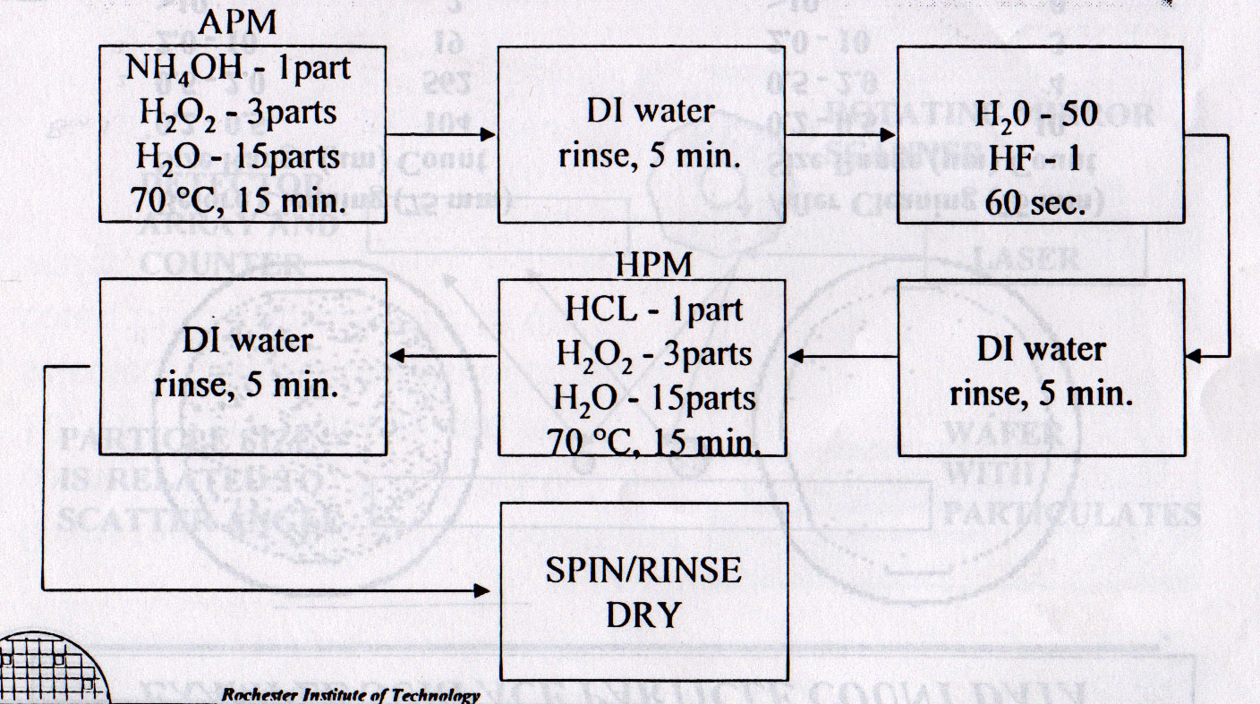

Figure 3: Furnace Process
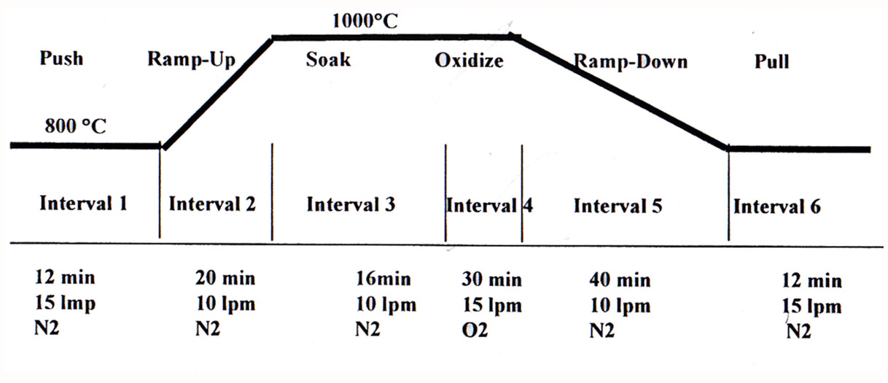

Figure 4: Gaussian Profile
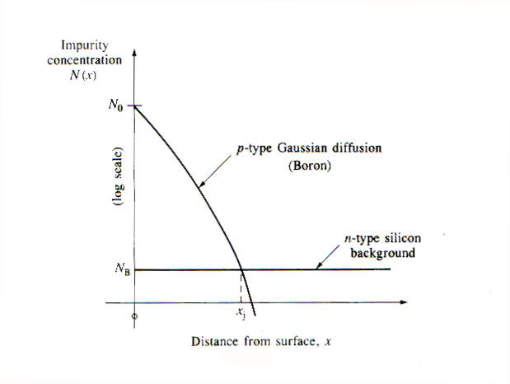

Figure 5: Lateral Diffusion
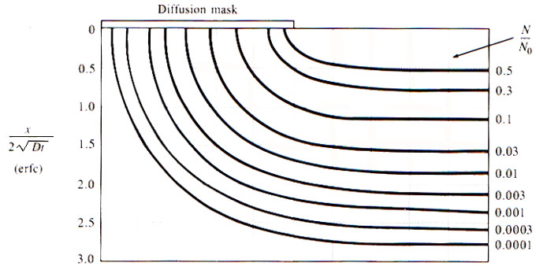

Figure 6: Resist Exposure
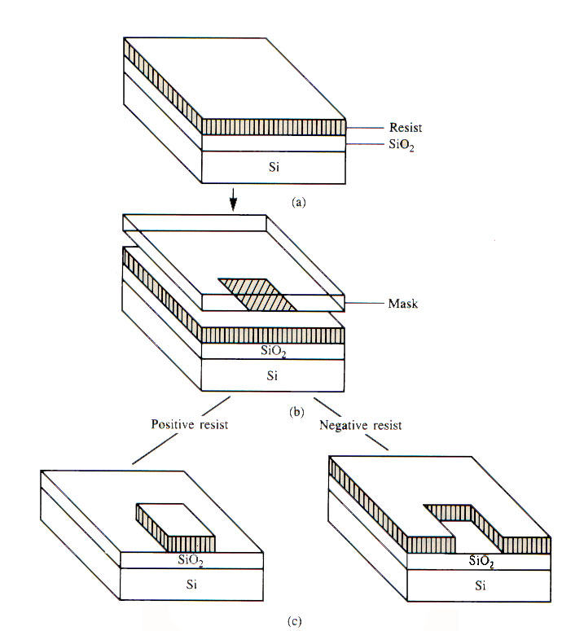

Figure 7: Etch/Ash Resist
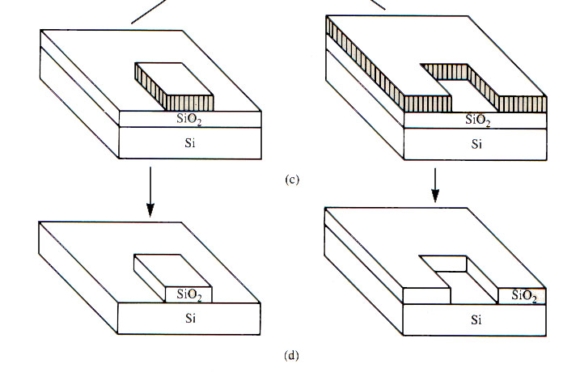

REFERENCES

- Jaeger, R. C.(1993, May).Introduction to Microelectronic Fabrication .(Modular Series On Solid State Devices; Vol 5).Reading, MA:Addison-Wesley
- Fuller,L.F.(2000).PMOS Testing at Rochester Institute of Technology. In EMCR350 Lab Manual. Rochester Institute of Technology.
- Fuller,L.F.(1999). Diffusion Laboratory. In EMCR350 Lab Manual. Rochester Institute of Technology.
- Fuller,L.F.(1999).Wafer Cleaning and Oxide Growth Laboratory. In EMCR350 Lab Manual. Rochester Institute of Technology.
- Rochester Institute of Technology. (1998) Process Master File Listing of Manufacturing Executon System Application. Report ID LTR254.
- Fuller,L.F.(1998). RIT PMOS Process. In EMCR350 Lab Manual. Rochester Institute of Technology.
- Electronic reference formats recommended by the American
Psychological Association. (2000, August 22). Washington, DC:
American Psychological Association. Retrieved May 2001, from
the World Wide Web: http://www.apa.org/journals/webref.html
- Electronic reference from Merriam-Webster Online. Retrieved May, 2001, from
the World Wide Web: http://www.webster.com/cgi-bin/dictionary.html
- American Institute of Physics. (1999). Transistorized!. Retrieved May 2001 from the World Wide Web: http://www.pbs.org/transistor/
- Markel, M. (1999). Technical Communication. 6th ed. Boston. Bedford/St. Martin’s
APPENDICES

